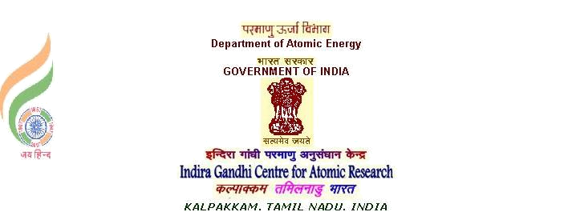

M.SIVARAMAKRISHNA | Phone : 044 27480500 -22491
SCIENTIFIC OFFICER ‘G | email : sivarama@igcar.gov.in
HEAD, INNOVOATIVE SENSORS SECTION
SISD, EIG, IGCAR
KALPAKKAM, KANCHIPURAM Dt,
TAMILNADU - 603102.

INTERNSHIP CERTIFICATE

I certify that that Ms. M.M.SHRIVIDHATRI (Roll no. 2019113006 ), second year CND student of IIIT, Hyderabad, has completed internship on “Literature survey for selection of suitable battery to support the inhouse development of innovative sensors" in IGCAR, DAE, during the month of December 2020, under my guidance.

During this period, her performance and conduct are satisfactory.

(M.SIVARAMAKRISHNA)
14/01/2021

